


PAYROLL MANAGEMENT SYSTEM

A PROJECT REPORT

Submitted by

NEHA HENIN J(2303811714822025)

in partial fulfillment of requirements for the award of the course
CGB1221-DATABASE MANAGEMENT SYSTEMS

in

ARTIFICIAL INTELLIGENCE AND MACHINE LEARNING

K. RAMAKRISHNAN COLLEGE OF TECHNOLOGY
(An Autonomous Institution, affiliated to Anna University Chennai and Approved by AICTE, New Delhi)

SAMAYAPURAM – 621 112

JUNE 2025

i

K. RAMAKRISHNAN COLLEGE OF TECHNOLOGY (AUTONOMOUS)
SAMAYAPURAM – 621 112

BONAFIDE CERTIFICATE

Certified that this project report on “ PAYROLL MANAGEMENT SYSTEM” is the bonafide work of NEHA HENIN J(2303811714822025) who carried out the project work during the academic year 2024 - 2025 under my supervision.

 | 
SIGNATURE Dr.T.AVUDAIAPPAN, M.E.,Ph.D., HEAD OF THE DEPARTMENT ASSOCIATE PROFESSOR  Department of Artificial Intelligence  K.Ramakrishnan College of Technology (Autonomous)  Samayapuram–621112. | SIGNATURE  Mr.R.ROSHAN JOSHUA, M.E.,  SUPERVISOR  ASSISTANT PROFESSOR  Department of Artificial Intelligence  K.Ramakrishnan College of Technology (Autonomous)  Samayapuram–621112.

Submitted for the viva-voce examination held on 04.06.2025




INTERNAL EXAMINER  ii | EXTERNAL EXAMINER

DECLARATION

I declare that the project report on “PAYROLL MANAGEMENT SYSTEM” is the result of original work done by us and best of our knowledge, similar work has not been submitted to “ANNA UNIVERSITY CHENNAI” for the requirement of Degree of BACHELOR OF ENGINEERING. This project report is submitted on the partial fulfilment of the requirement of the completion of the course CGB1221 – DATABASE MANAGEMENT SYSTEMS.
.

Signature

NEHA HENIN J

Place: Samayapuram Date:04.06.2025

ACKNOWLEDGEMENT

It is with great pride that I express our gratitude and in-debt to our institution “K.Ramakrishnan College of Technology (Autonomous)”, for providing us with the opportunity to do this project.

I glad to credit honourable chairman Dr. K. RAMAKRISHNAN, B.E., for having provided for the facilities during the course of our study in college.

I would like to express our sincere thanks to our beloved Executive Director Dr. S. KUPPUSAMY, MBA, Ph.D., for forwarding to our project and offering adequate duration in completing our project.

I would like to thank Dr. N. VASUDEVAN, M.Tech., Ph.D., Principal, who gave opportunity to frame the project the full satisfaction.

I whole heartily thanks to Dr. T. AVUDAIAPPAN, M.E.,Ph.D., Head of the department, ARTIFICIAL INTELLIGENCE for providing his encourage pursuing this project.

I express our deep expression and sincere gratitude to our project supervisor
Mr.R.ROSHAN JOSHUA, M.E., Department of ARTIFICIAL INTELLIGENCE,
for his incalculable suggestions, creativity, assistance and patience which motivated us to carry out this project.

I render our sincere thanks to Course Coordinator and other staff members for providing valuable information during the course.

I wish to express our special thanks to the officials and Lab Technicians of our departments who rendered their help during the period of the work progress.

INSTITUTE

Vision:
- To serve the society by offering top-notch technical education on par with global standards.

Mission:
- Be a center of excellence for technical education in emerging technologies by exceeding the needs of industry and society.
- Be an institute with world class research facilities.
- Be an institute nurturing talent and enhancing competency of students to transform them as all – round personalities respecting moral and ethical values.

DEPARTMENT

Vision:

- To become a renowned hub for AIML technologies to producing highly talented globally recognizable technocrats to meet industrial needs and societal expectation.

Mission

- To impart advanced education in AI and Machine Learning, built upon a foundation in Computer Science and Engineering.
- To foster Experiential learning equips students with engineering skills to tackle real-world problems.
- To promote collaborative innovation in AI, machine learning, and related research and development with industries.
- To provide an enjoyable environment for pursuing excellence while upholding strong personal and professional values and ethics.

PROGRAM EDUCATIONAL OBJECTIVES (PEO)

- PEO1: Excel in technical abilities to build intelligent systems in the fields of AI & ML in order to find new opportunities.
- PEO2: Embrace new technology to solve real-world problems, whether alone or as a team, while prioritizing ethics and societal benefits.
- PEO3: Accept lifelong learning to expand future opportunities in research and product development.

PROGRAM SPECIFIC OUTCOMES (PSO)
- PSO1: Expertise in tailoring ML algorithms and models to excel in designated applications and fields.
- PSO2: Ability to conduct research, contributing to machine learning advancements and innovations that tackle emerging societal challenges.

PROGRAM OUTCOMES (POs)
Engineering students will be able to:

- Engineering knowledge: Apply the knowledge of mathematics, science, engineering fundamentals, and an engineering specialization to the solution of complex engineering problems.
- Problem analysis: Identify, formulate, review research literature, and analyze complex engineering problems reaching substantiated conclusions using first principles of mathematics, natural sciences, and engineering sciences
- Design/development of solutions: Design solutions for complex engineering problems and design system components or processes that meet the specified needs with appropriate consideration for the public health and safety, and the cultural, societal, and environmental considerations
- Conduct investigations of complex problems: Use research-based knowledge and research methods including design of experiments, analysis and interpretation of data, and synthesis of the information to provide valid conclusions

- Modern tool usage: Create, select, and apply appropriate techniques, resources, and modern engineering and IT tools including prediction and modeling to complex engineering activities with an understanding of the limitations
- The engineer and society: Apply reasoning informed by the contextual knowledge to assess societal, health, safety, legal and cultural issues and the consequent responsibilities relevant to the professional engineering practice
- Environment and sustainability: Understand the impact of the professional engineering solutions in societal and environmental contexts, and demonstrate the knowledge of, and need for sustainable development
- Ethics: Apply ethical principles and commit to professional ethics and responsibilities and norms of the engineering practice.
- Individual and team work: Function effectively as an individual, and as a member or leader in diverse teams, and in multidisciplinary settings.
- Communication: Communicate effectively on complex engineering activities with the engineering community and with society at large, such as, being able to comprehend and write effective reports and design documentation, make effective presentations, and give and receive clear instructions.
- Project management and finance: Demonstrate knowledge and understanding of the engineering and management principles and apply these to one’s own work, as a member and leader in a team, to manage projects and in multidisciplinary environments.
- Life-long learning: Recognize the need for, and have the preparation and ability to engage in independent and life-long learning in the broadest context of technological change.

ABSTRACT

The Payroll Management System is a web-based application designed to streamline and automate the payroll processing tasks within an organization. It is developed using PHP for server-side scripting, MySQL for database management, and Bootstrap for creating a responsive user interface. The system provides secure login and registration features with password hashing and session management to ensure only authorized access. It allows administrators to perform CRUD operations on employee and payroll records efficiently. A dashboard displays key metrics such as the total number of employees and the total amount of payroll disbursed using SQL aggregate functions. The use of PDO (PHP Data Objects) enhances database security by preventing SQL injection attacks. This system reduces the dependency on manual payroll methods, increases accuracy, and saves time in salary disbursement processes. The application is designed to be scalable, allowing for future enhancements like leave tracking, payslip generation, email notifications, and role-based access controls. The main objective of this project is to eliminate manual payroll processing, reduce errors, and save time by providing a centralized platform for payroll operations. With features such as password hashing, employee and payroll CRUD operations, and dashboard summaries, the system demonstrates an efficient solution for small to medium-sized businesses.

ABSTRACT WITH POs AND PSOs MAPPING

CO 5: BUILD DATABASE MANAGEMENT SYSTEM APPLICATION FOR SOLVING REAL- TIME PROBLEMS

ABSTRACT | POs MAPPED | PSOs MAPPED
This project focuses on developing a Payroll Management
System that automates the process of managing employee
 | PO1 -3
data and generating payroll information. By utilizing PHP as | PO2 -3
the backend language, MySQL as the database, and Bootstrap | PO3 -3
for styling, the system ensures both functionality and | PO4 -3
responsiveness. The application enables secure user registration and login, with features like password encryption and session control. It allows for efficient handling of | PO5 -3  PO6 -3  PO7 -3  PO8 -3 | PSO1 -3  PSO2 -3  PSO3 -3
 | PO9 -3
employee records and salary disbursements, offering | PO10 -3
modules for data entry, updating, and deletion. Real-time | PO11-3
dashboard statistics give users a clear overview of payroll and | PO12 -3
workforce data.
Note: 1- Low, 2-Medium, 3- High

TABLE OF CONTENTS

CHAPTER NO. TITLE

PAGE NO.

ABSTRACT viii
- INTRODUCTION 1
  - Objective 1
  - Overview 1
  - SQL and Database concepts 2
- PROJECT METHODOLOGY 4
  - Proposed Work 4
  - Block Diagram 5
- MODULE DESCRIPTION 6
  - User Authentication Module 6
  - Employee Management Module 6
  - Payroll Management Module 6
  - Dashboard Module 7
  - Database Connectivity and Security Module 7
- CONCLUSION & FUTURE SCOPE 8
- APPENDIX A SOURCE CODE 10
APPENDIX B SCREENSHOTS 18
REFERENCES 20

LIST OF FIGURES

FIG NO. TITLE PAGE NO.
2.1 Block Diagram 5

5.1 Login page 18

5.2 List of collected data 18

5.3 Dashboard page 18

5.4 View of payroll management 19

5.5 Viewing total data connectivity 19
LIST OF ABBREVIATIONS

ABBREVIATIONS

UTF - UniCode Transformation Function
CRUD - Create, Read, Update, Delete
JSON - JavaScript Object Notation
HTML - Hyper Text Markup Language
SQL - Structured Query Language

Objective

CHAPTER 1 INTRODUCTION

The primary objective of the Payroll Management System is to develop a robust application that automates the management of employee data, salary calculations, and payroll processing. The system ensures accuracy, consistency, and efficiency in managing employee salaries, generating payslips, tracking attendance, and handling payroll records. It reduces manual workload and minimizes the chances of errors in salary processing.

Overview
The Payroll Management System is a web-based application developed using PHP, MySQL (XAMPP), HTML, CSS, JavaScript, and Bootstrap for responsive design. It is designed to handle core payroll functions such as:
    - Employee registration and details management
    - Salary generation based on employee role and monthly input
    - Payroll record keeping (monthly payments, history)
    - User authentication for admin-level security
    - Dashboard showing summaries like total employees and total payments made
The system is user-friendly, secure, and scalable for small to medium organizations that want a centralized payroll solution.

SQL and Database Concepts
Basic SQL & Database Concepts Used:
- Database: A structured collection of employee and payroll-related data.

Tables:
  - users – for login and registration
  - employees – for storing employee information
  - payroll – for tracking employee payments

SQL Statements Used:
  - CREATE TABLE, INSERT, SELECT, UPDATE, DELETE
  - JOIN (to combine data from payroll and employees)
  - COUNT(), SUM() for dashboard summaries

- Normalization: The database is normalized to reduce redundancy— employee and payroll data are kept in separate linked tables.

Constraints:
  - PRIMARY KEY on IDs
  - FOREIGN KEY in payroll table linking to employee ID

Data Integrity:
  - Using proper data types (INT, VARCHAR, DECIMAL)
  - Validation through PHP and form controls

ProjectSpecific SQL Concepts:
  - Secure User Authentication: Passwords are hashed and stored securely using PHP's password_hash() and verified with password_verify().

  - Relational Design: The payroll system uses relational database design principles. For example:
    - employee_id in the payroll table is a foreign key that references the employees table.

Dashboard Aggregations:
    - SELECT COUNT(*) FROM employees — counts total employees
    - SELECT SUM(amount) FROM payroll — calculates total salary paid

Security Concepts:
    - Passwords stored using password hashing.
    - User input validated before database entry.

Data Types:
    - VARCHAR for names/emails
    - INT for IDs
    - DECIMAL(10,2) for salary/amount
    - DATE or VARCHAR for payroll month

Form to Database Interaction:

    - Frontend forms are connected to backend using PHP and PDO (PHP Data Objects) for secure DB interaction.

Error Handling:

    - Try-catch blocks in PHP used to handle duplicate entries and other SQL exceptions
    - Ensure all user inputs (e.g., salary amount, tax entries, leave entries) are validated before processing to prevent invalid data errors.
    - Provide clear and user-friendly error messages that help users understand what went wrong and how to fix it.

CHAPTER 2

PROJECT METHODOLOGY

Proposed Work
The proposed work focuses on designing and implementing a web-based Payroll Management System that automates the process of managing employee records and salary payments. The system aims to improve accuracy, efficiency, and transparency in payroll processing while minimizing manual errors and administrative overhead.

Key Features of the Proposed System:
    - User Authentication
      - Secure login and registration for administrators using hashed passwords.
      - Session management to restrict unauthorized access.

Employee Management Module
      - Add, view, and delete employee details such as name, position, and salary.
      - Simple and responsive interface for easy employee record handling.

Payroll Management Module
      - Allows entry of monthly payroll for each employee.
      - Captures amount paid, employee ID, and month of payment.
      - Data linked with employee details using relational database principles.

Dashboard Summary
      - Displays the total number of employees and total payroll paid.
      - Real-time stats using SQL COUNT() and SUM() functions.

Database Connectivity using PDO
      - Secure communication between the web application and MySQL database using PHP Data Objects (PDO).

Responsive Design
      - Use of Bootstrap 5 to ensure mobile-friendly, user-responsive interface.

Data Validation
      - Both client-side and server-side validation to ensure only valid data is stored.

Error Handling
      - Use of try-catch blocks for safe execution of SQL queries and handling duplicates or constraint violations.

Block Diagram

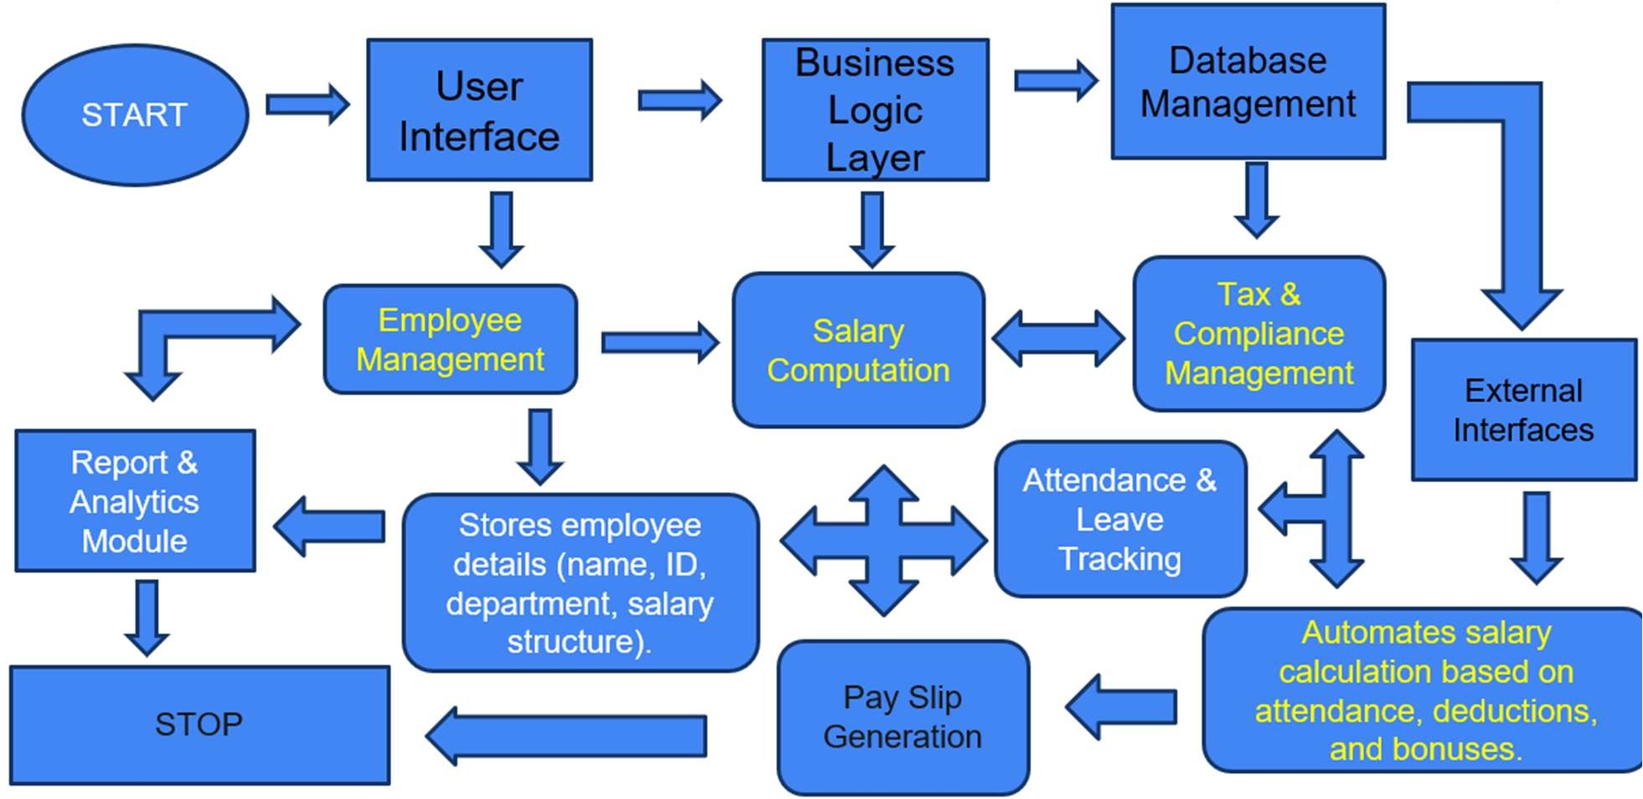

Fig2.1:Block diagram

CHAPTER 3 MODULE DESCRIPTION

Module 1 : User Authentication Module
This module handles the login and registration process for the administrator. It includes:
    - User registration with validation and password hashing using password_hash().
    - Login using password_verify() to authenticate the user.
    - Session management to restrict access to authorized users only.
    - Logout functionality to end the session securely.

Module 2 : Employee Management Module
This module allows the admin to manage employee data. It includes:
    - Adding new employee details (name, position, salary).
    - Displaying a list of all employees.
    - Deleting employee records.
    - Secure storage of employee data in the employees table

Module 3 : Payroll Management Module
This module processes and stores payroll transactions. It includes:
    - Assigning salary payments to employees based on employee ID.
    - Input for pay month and amount.
    - Viewing all payroll records with employee names using SQL JOIN.
    - Deleting specific payroll entries.

Module 4 : Dashboard Module
This module provides an overview of system statistics. It displays:
    - Total number of employees (COUNT() function).
    - Total payroll amount paid (SUM() function).
    - Helps the admin monitor payroll activity at a glance.

Module 5 : Database Connectivity and Security Module
This module ensures safe and secure communication between the application MySQL database. It includes:
    - PDO (PHP Data Objects) for executing database queries securely.
    - Prepared statements to prevent SQL injection.
    - Exception handling for query errors and duplicate entries.
    - Implement PDO (PHP Data Objects) or MySQLi for secure and flexible database connections (if using PHP).
    - Enable Create, Read, Update, Delete functionality for employee records, payroll entries, attendance logs, etc.

CHAPTER 4
CONCLUSION AND FUTURE ENHANCEMENT CONCLUSION
The Payroll Management System successfully automates the essential payroll processes such as employee registration, salary management, and monthly payroll generation. Through a secure login system and user-friendly interface, the administrator can efficiently manage employee records and salary transactions with reduced manual errors. The use of PHP with PDO, MySQL, and Bootstrap ensures smooth functionality, responsive design, and secure data handling.
This project demonstrates how digital solutions can streamline payroll operations, improve accuracy, and save administrative time and effort.

FUTURE ENHANCEMENT
To further enhance the capabilities of the system, the following improvements can be considered:

Role-Based Access Control
  - Add multiple user roles (e.g., HR, Accountant) with different privileges.

Payroll Report Generation (PDF/Excel)
  - Generate printable reports for monthly salary disbursements.

Employee Self-Service Portal
  - Allow employees to log in, view payslips, and update personal information.

Email Notification System
  - Send automatic emails to employees regarding salary credits or updates.

Leave and Attendance Integration
  - Include leave management to automate salary deduction based on attendance.
  - Implement user roles such as Admin, HR, and Employee with different access permissions for enhanced security and functionality.
  - Support for various leave types (paid leave, sick leave, casual leave, unpaid leave) with customizable policies.

Cloud Deployment
  - Host the system online for remote access and scalability.
  - Easily scale the system up or down based on the number of employees or business needs.
  - Support multiple branches or organizations from a single platform.
  - Schedule regular automated backups on the cloud infrastructure.

Data Backup and Restore Feature
  - Implement backup solutions for data safety and recovery.
  - Store backups in encrypted formats to prevent unauthorized access.
  - Keep logs of backup and restore operations for security and compliance tracking.
  - Notify admins about backup success/failure via email or SMS.

APPENDIX A
SOURCE CODE:
SQL CODE:
CREATE TABLE users (
id INT AUTO_INCREMENT PRIMARY KEY, username VARCHAR(50) NOT NULL UNIQUE, email VARCHAR(100),
password VARCHAR(255) NOT NULL
);

CREATE TABLE employees (
id INT AUTO_INCREMENT PRIMARY KEY, name VARCHAR(100),
position VARCHAR(100), salary DECIMAL(10,2)
);

CREATE TABLE payroll (
id INT AUTO_INCREMENT PRIMARY KEY,
employee_id INT, pay_month VARCHAR(20), amount DECIMAL(10,2),
FOREIGN KEY (employee_id) REFERENCES employees(id)
);

PHP CODE:
<?php session_start();
$host = 'localhost';
$db = 'payroll_db';
$user = 'root';
$pass = '';
$dsn = "mysql:host=$host;dbname=$db;charset=utf8mb4";
$pdo = new PDO($dsn, $user, $pass);

// Handle Register
if (isset($_POST['register'])) {
$uname = $_POST['username'];
$email = $_POST['email'];
$password = password_hash($_POST['password'], PASSWORD_DEFAULT);
$stmt = $pdo->prepare("INSERT INTO users (username, email, password) VALUES (?, ?, ?)");
try {
$stmt->execute([$uname, $email, $password]);
echo "<script>alert('Registration successful!');</script>";
} catch (PDOException $e) {
echo "<script>alert('Username already taken.');</script>";
}
}

// Handle Login
if (isset($_POST['login'])) {
$uname = $_POST['username'];
$password = $_POST['password'];
$stmt = $pdo->prepare("SELECT * FROM users WHERE username=?");
$stmt->execute([$uname]);
$user = $stmt->fetch();
if ($user && password_verify($password, $user['password'])) {
$_SESSION['user'] = $user['username'];
} else {
echo "<script>alert('Invalid login credentials.');</script>";
}
}

// Handle Logout
if (isset($_GET['logout'])) { session_destroy(); header("Location: index.php"); exit;
}

// CRUD Operations for Employees if (isset($_POST['add_employee'])) {
$stmt = $pdo->prepare("INSERT INTO employees (name, position, salary) VALUES (?, ?, ?)");

$stmt->execute([$_POST['name'], $_POST['position'], $_POST['salary']]);
}

if (isset($_GET['delete_emp'])) {
$stmt = $pdo->prepare("DELETE FROM employees WHERE id=?");
$stmt->execute([$_GET['delete_emp']]);
}

// CRUD Operations for Payroll
if (isset($_POST['add_payroll'])) {
$stmt = $pdo->prepare("INSERT INTO payroll (employee_id, pay_month, amount) VALUES (?, ?, ?)");
$stmt->execute([$_POST['emp_id'], $_POST['month'], $_POST['amount']]);
}

if (isset($_GET['delete_pay'])) {
$stmt = $pdo->prepare("DELETE FROM payroll WHERE id=?");
$stmt->execute([$_GET['delete_pay']]);
}
?>

<!DOCTYPE html>
<html>
<head>
<title>Payroll Management</title>

<link href="https://cdn.jsdelivr.net/npm/bootstrap@5.3.0/dist/css/bootstrap.min.css" rel="stylesheet">
<style>body { padding: 30px; }</style>
</head>
<body>
<div class="container">

<?php if (!isset($_SESSION['user'])): ?>
<div class="row">
<div class="col-md-6">
<h3>Login</h3>
<form method="POST">
<input name="username" class="form-control mb-2" required placeholder="Username">
<input type="password" name="password" class="form-control mb-2" required placeholder="Password">
<button name="login" class="btn btn-primary">Login</button>
</form>
</div>
<div class="col-md-6">
<h3>Register</h3>
<form method="POST">
<input name="username" class="form-control mb-2" required placeholder="Username">
<input name="email" type="email" class="form-control mb-2" required

placeholder="Email">
<input type="password" name="password" class="form-control mb-2" required placeholder="Password">
<button name="register" class="btn btn-success">Register</button>
</form>
</div>
</div>
<?php else: ?>
<h3>Welcome, <?= $_SESSION['user'] ?> <a href="?logout=1" class="btn btn- danger btn-sm">Logout</a></h3>

<!-- Dashboard -->
<h4>Dashboard</h4>
<?php
$empCount = $pdo->query("SELECT COUNT(*) FROM employees")-
>fetchColumn();
$payTotal = $pdo->query("SELECT SUM(amount) FROM payroll")-
>fetchColumn();
?>
<div class="row mb-4">
<div class="col-md-6"><div class="alert alert-info">Total Employees: <?=
$empCount ?></div></div>
<div class="col-md-6"><div class="alert alert-success">Total Payroll Paid:
₹<?= number_format($payTotal,2) ?></div></div>
</div>

<!-- Employee Management -->
<h4>Employee Management</h4>
<form method="POST" class="row g-2">
<input name="salary" required class="form-control" type="number" step="0.01" placeholder="Salary">
<button name="add_employee" class="btn btn-primary mt-2">Add Employee</button>
</form>
<table class="table mt-3">

<tr><th>ID</th><th>Name</th><th>Position</th><th>Salary</th><th>Action</th
></tr>
<?php foreach ($pdo->query("SELECT * FROM employees") as $row): ?>
<tr>
<td><?= $row['id'] ?></td><td><?= $row['name'] ?></td>
<td><?= $row['position'] ?></td><td>₹<?= $row['salary'] ?></td>
<td><a href="?delete_emp=<?= $row['id'] ?>" class="btn btn-sm btn- danger">Delete</a></td>
</tr>
<?php endforeach; ?>
</table>

<!-- Payroll Management -->
<h4>Payroll Management</h4>
<form method="POST" class="row g-2">
<select name="emp_id" class="form-control" required>

<option value="">Select Employee</option>
<?php foreach ($pdo->query("SELECT * FROM employees") as $emp): ?>
<option value="<?= $emp['id'] ?>"><?= $emp['name'] ?></option>
<?php endforeach; ?>
</select>
<input name="month" required class="form-control" placeholder="Month">
<input name="amount" required class="form-control" type="number" step="0.01" placeholder="Amount">
<button name="add_payroll" class="btn btn-success mt-2">Add Payroll</button>
</form>
<tr><th>ID</th><th>Employee</th><th>Month</th><th>Amount</th><th>Action
</th></tr>

<td><?= $row['id'] ?></td><td><?= $row['name'] ?></td>
<td><?= $row['pay_month'] ?></td><td>₹<?= $row['amount'] ?></td>
<td><a href="?delete_pay=<?= $row['id'] ?>" class="btn btn-sm btn- danger">Delete</a></td>
</tr>
<?php endforeach; ?>
</table>

<?php endif; ?>
</div>
</body>
</html>

APPENDIX B
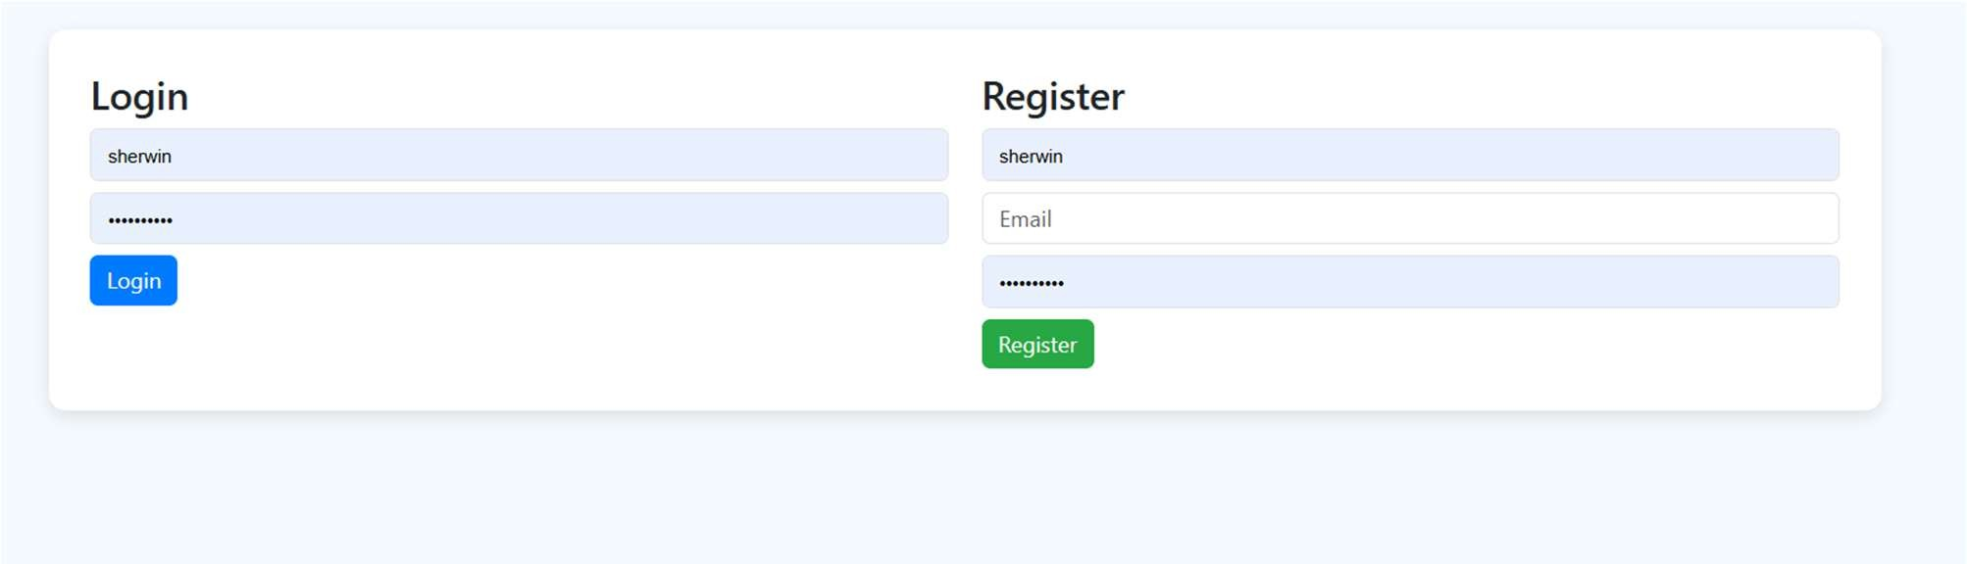
Fig 5.1: Login page
DATABASE CONNECTIVITY

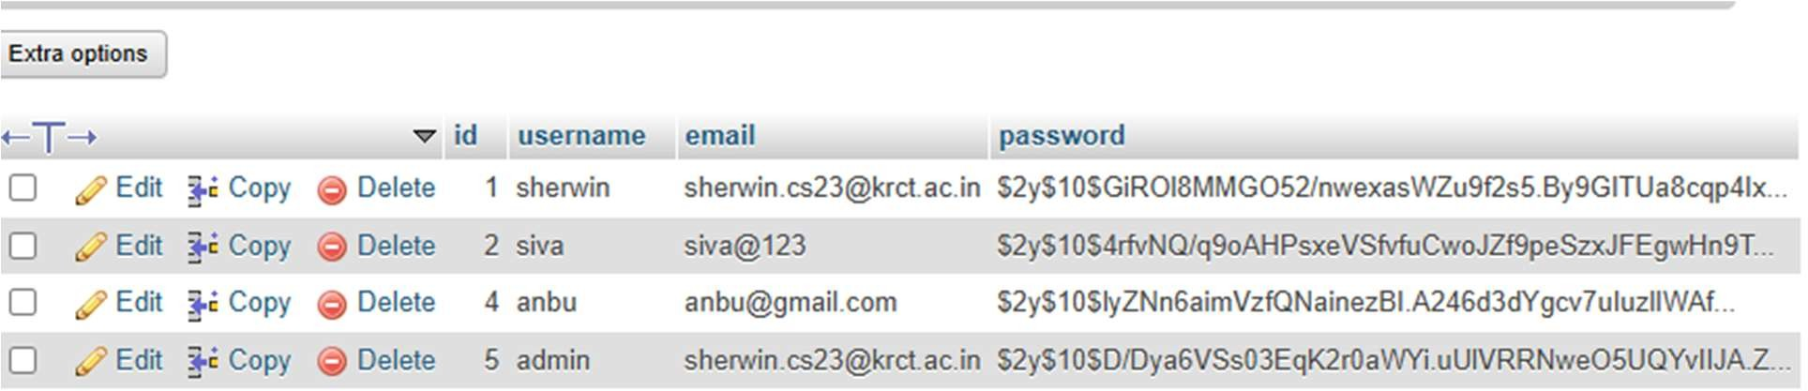

Fig 5.2: List of collected data

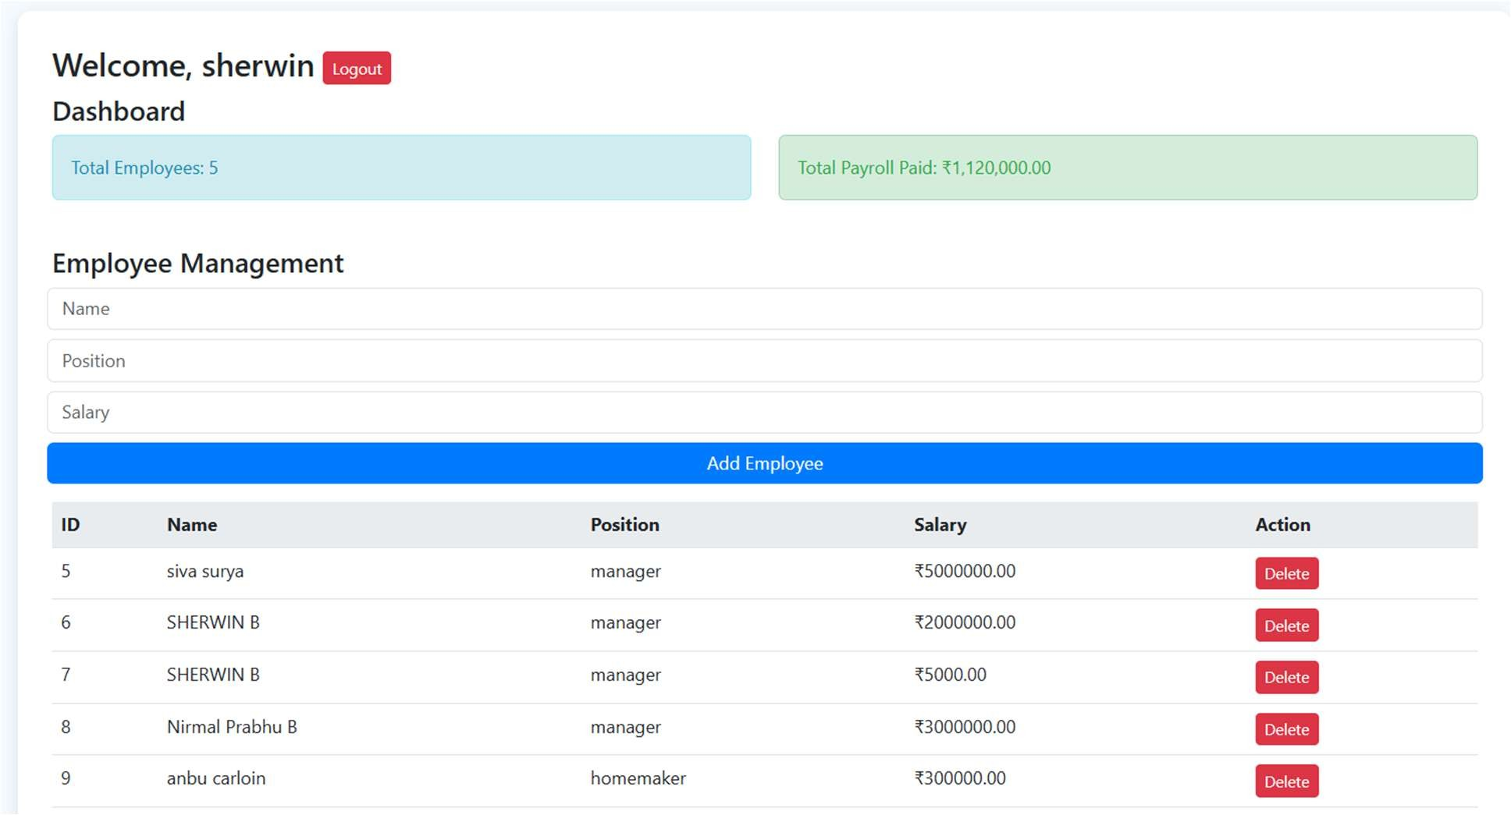

Fig 5.3: Dashboard page
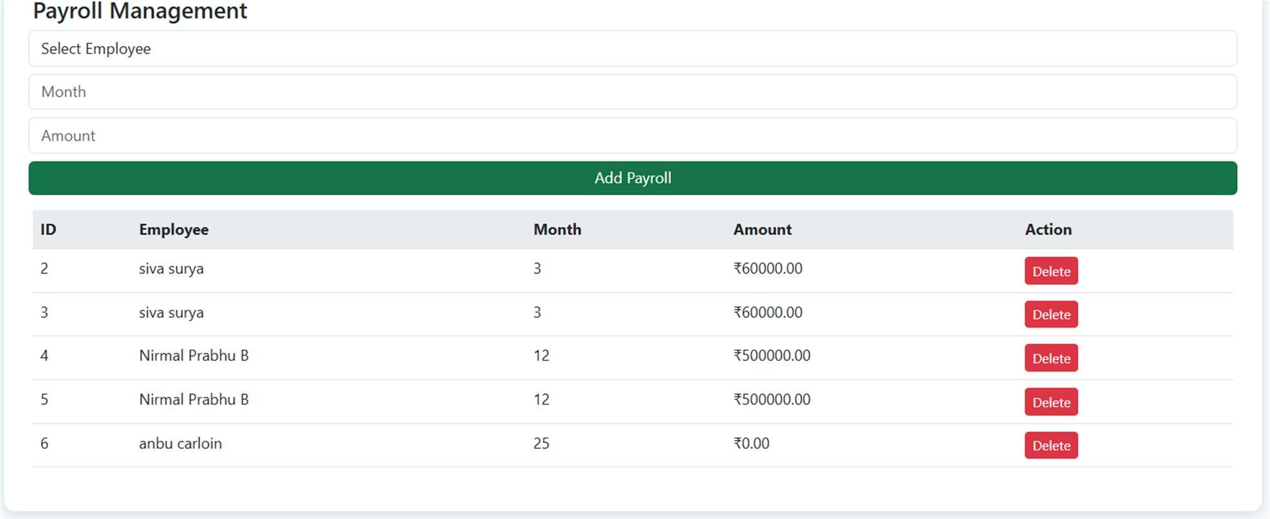
Fig 5.4: View of Payroll management

DATABASE CONNECTIVITY
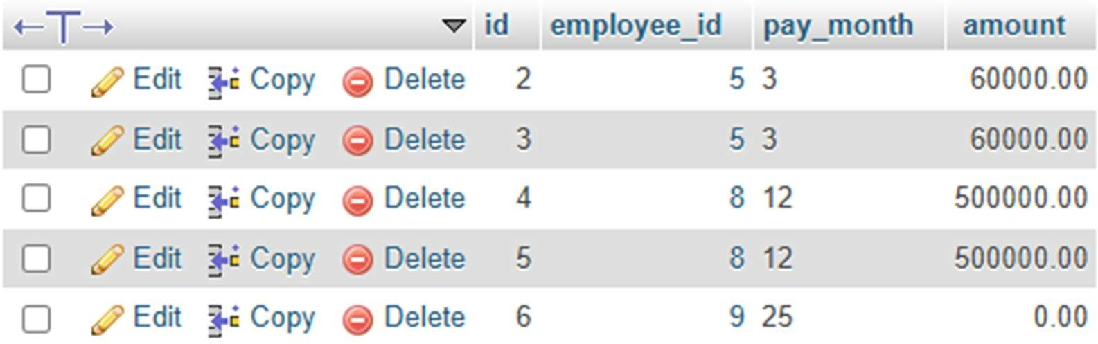

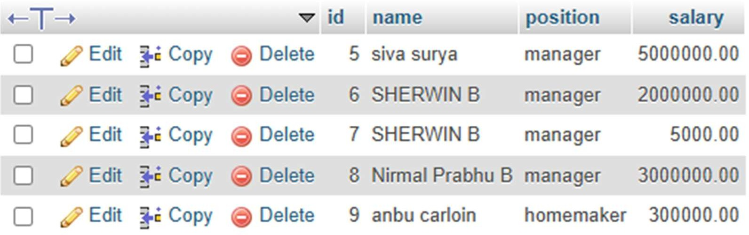
Fig 5.5: viewing total data connectivity

REFERENCES:

- Database Management Systems – Raghu Ramakrishnan, Johannes Gehrke

- Database System Concepts – Abraham Silberschatz, Henry Korth, S. Sudarshan
- https://www.w3schools.com/php/ — PHP and MySQL tutorials

- https://www.mysql.com/ — Official MySQL documentation

- https://getbootstrap.com/ — Bootstrap framework for responsive design

- https://www.tutorialspoint.com/php/ — PHP reference materials

- YouTube – "PHP MySQL CRUD Tutorial" by CodeWithHarry

- YouTube – "PDO Tutorial for Beginners" by Programming with Mosh

- Stack Overflow – https://stackoverflow.com — Community for debugging

and learning

- XAMPP – https://www.apachefriends.org/ — Local server environment

setup

